WORK INTERGRATED LEARNING
MODULE CODE: XISD5319

TASK 2

TEAM NAME: Core3 Systems

GROUP MEMBERS
RAFIQAH KIRBY - ST10438554
ARMALENE MAGERMAN - ST10454097
CHLOE LANGENHOVEN - ST10435895


NAME OF CLIENT
Iziko Museums of South Africa
(ART GALLERY)
Chief Educator: Art - Rory Emmett

Table of Contents
Introduction 4
Logical Architectural Design 6
High Level Architectural Design 6
Functional building blocks 6
Low-Level Architectural Design 7
Actors 7
Functions (Use Cases) 7
Database Tables 7
Interactions With The User 9
Input Interactions 9
Request interactions 11
Database design 14
Identified Entities 14
Entity Relationships 15
Database Normalisation 15
Database Table 1: User 16
Database Table 2: Artist 16
Database Table 3: Category 17
Database Table 4: Artwork 17
Database Table 5: Favourite 17
ERD DIAGRAM 18
Entity Relationship Database Design 19
Database tables and fields 19
Key relationships 19
System Reports Design 21
Types of Reports Table 21
Report Input and Output Design 22
Input Data Table 22
Output Data Table 22
Example Report Layout 23
Report 1: User Activity Report 23
Report 2: Artwork Usage Report 23
Report 3: QR Code Scan Report 24
System Report Process 25
Security and Access Control 25
References 26
Github 27
GitHub Link : 27
What can be found on GitHub: 27

Introduction
System Design objective is to showcase the technical and architectural design of the suggested mobile application for South Africa's Iziko Museums. By outlining how the system will be organized and put into use to satisfy the needs of the company and its users, this document expands on the earlier stages of project planning and requirement analysis.
The proposed system is a mobile application designed to provide access to educational museum content and African artwork via digital technology. By enabling visitors to browse art collections, learn historical details, view instructional videos, and engage with museum content via their mobile devices, the program seeks to modernize the museum experience. For visitors, students, researchers, and younger audiences who might not always be able to physically visit the museum, the system is specifically designed to improve accessibility.
As it converts the functional and non-functional requirements found during system analysis into a structured technological solution, the system design phase is crucial to the systems development life cycle. System design, according to Sommerville (2016), focuses on specifying the architecture, parts, interfaces, and data structures necessary to successfully create a software system. All system requirements are turned into workable technological solutions that enable system functioning, usability, and maintainability thanks to the design process.
Android Studio and Kotlin will be used to create the suggested mobile application, and MySQL will be utilized for database administration. The system will use a client-server architecture, with the database server managing and storing user and artwork data and the mobile application serving as the client interface. Digital artwork galleries, QR code scanning, multimedia content, search capabilities, favourite management, and administrative content management tools are just a few of the features that will be included in the application.
The challenges and concerns found during the project planning stage are also considered in the system design. The group acknowledged certain limitations, including limited development experience, restricted access to testing devices, and challenges with internet connectivity. The structure makes use of cloud-based storage systems, Android emulators, and backup programs like GitHub to solve these problems. By taking these steps, you may increase dependability and lower the chance of data loss or development disruptions.
The application's design places a high priority on scalability, accessibility, and usability. For people with varying degrees of technological expertise, the user interface will be made to be easy to use and navigate. Future growth will also be supported by the system, enabling the integration of new features and content as the museum's digital needs increase.
The Iziko Museums of South Africa will have a cutting edge digital platform that facilitates cultural preservation, educational engagement, and global accessibility through mobile technology if this concept is successfully implemented.

Logical Architectural Design

High Level Architectural Design
The Iziko Museum Mobile Application uses a three-level (three-tier) client-server architecture. This means the system is divided into three separate layers, each with its own job. The three layers are:
- Client Layer — the Android mobile application that runs on the user's phone or tablet.
- Application Layer — the server that receives requests from the app and processes them (business logic).
- Database Layer — where all data is stored and managed using MySQL for structured data and Firebase for cloud-based real-time storage.

Functional building blocks

Functions on the client include displaying artwork, scanning QR codes, watching videos, navigating menus, and saving favourites. Functions on the server include processing login authentication, managing artwork records, generating reports, and handling user data. This separation ensures the app runs smoothly even on lower-end devices (Hoffer, George and Valacich, 2016).
Referring to the logical system model in the Analysis Document, users give inputs like login details, search keywords, and QR code scans. The server processes these and sends back outputs such as artwork information, videos, and reports to the user's screen. The main functions of the system include browsing artwork, scanning QR codes, watching educational videos, managing user accounts, uploading content, and generating usage reports (referring to the functional requirements table in the Analysis Document).
Figure 1: High-Level Three-Tier Architectural Design
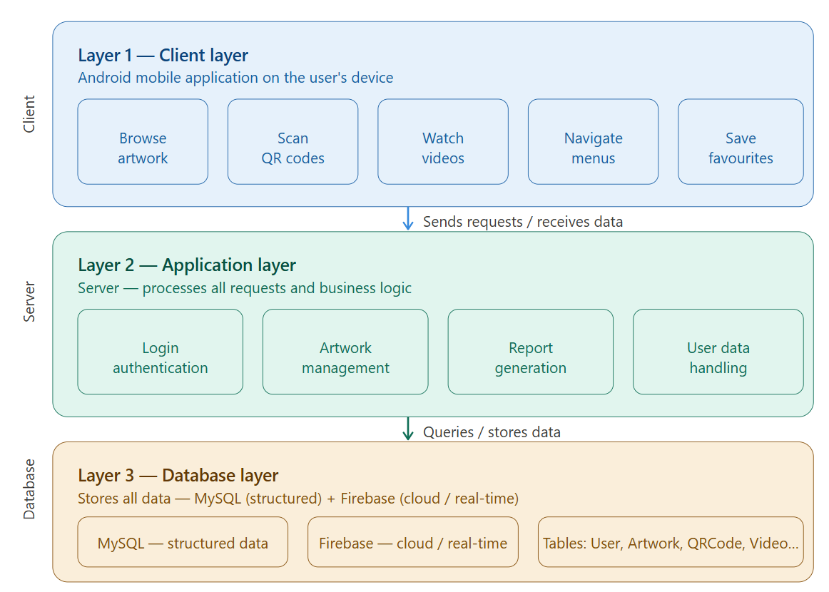
Figure 1:The three-level architecture separates the mobile client, application server and database. Source: Sommerville (2016).

Low-Level Architectural Design
The low-level architectural design shows the detailed relationships between the actors, the system functions (use cases), and the database tables. The diagram has three columns: Actors on the left, Functions (Use Cases) in the middle, and Database Tables on the right. Arrows show which actor triggers which function, and which database table is used.

Actors
- Visitor / User — browses artwork, scans QR codes, watches videos, saves favourites, registers, and logs in.
- Admin — uploads artwork, manages users, and generates reports.

Functions (Use Cases)
The main use cases are: Register User, Login, Browse Artwork, Scan QR Code, Watch Video, Save Favourite, Upload Artwork, Manage Users, and Generate Report. Login must be completed before any other function can be accessed (Kendall and Kendall, 2019).

Database Tables
Each use case connects to one or more database tables: User Table, Artwork Table, QR Code Table, Video Table, Favourite Table, and UserActivity Table. For example, Register User connects to the User Table, Browse Artwork connects to the Artwork Table, and Generate Report connects to the UserActivity Table (Satzinger, Jackson and Burd, 2016).

Figure 2: Low-Level Design Diagram
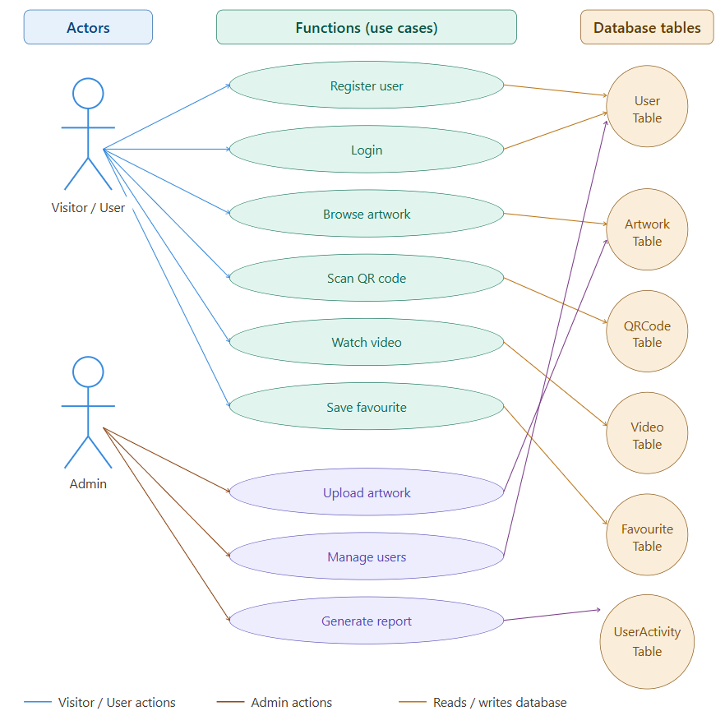
Figure 2: Low-level design showing actors, use cases, and their connected database tables. Source: Satzinger, Jackson and Burd (2016).

Interactions With The User

Input Interactions
The Iziko Museum mobile application's input interactions show how users enter, organize, and engage with data. These interactions, which are a component of the graphical user interface (GUI), enable the system to efficiently collect, process, and store data. Since it guarantees accurate, efficient, and consistent data entry, input design is a crucial component of system design, according to Hoffer, George, and Valacich (2016). User registration, artwork viewing, QR code scanning, content management, and report production are just a few of the user input interactions included in the proposed mobile application. The input menus are arranged in a hierarchical fashion to enhance user experience and navigation.
The input interactions were created to give both system administrators and visitors a straightforward, well-organized, and easy-to-use experience. User registration, authentication, and engagement with digital art collections are the main topics of the Visitor/User section. During the registration process, users will be able to securely log into the application with usernames and passwords.
Users can search for artwork, peruse collections, and obtain comprehensive details on artists and shows through the Artwork Gallery feature. Users can quickly obtain more information digitally by scanning artwork codes within the museum thanks to QR code scanning capability. Users can manage their personal information, preferences, and favourite artwork in the User Profile section. This enhances the application's user engagement and personalization.
Authorized staff personnel can upload and manage user data, instructional films, and artwork records using the Administration section's management features. Through the application dashboard, these input options guarantee that museum content may be updated effectively.
Administrators can create reports, keep an eye on user behaviour, check system utilization, and handle backups using the Reports area. These features enhance system maintenance and facilitate decision-making.
The input interaction structure follows the hierarchical menu approach recommended by system design principles because it improves navigation, reduces user confusion, and fosters usability (Kendall & Kendall, 2019). The separation of menus into first level and second level interactions also encourages future scalability by making it possible to incorporate additional features into the system as needed.

Menu Level | Visitor/User | Artwork Gallery | User Profile | Administrator | Reports
1st Level | Registration | Browse Artwork | Profile Information | Artwork Management | Usage Reports
2nd Level | Enter Full Name | View Categories | View Profile | Add Artwork | Generate Report
2nd Level | Enter Email Address | Search Artwork | Update Details | Edit Artwork | Export Report
2nd Level | Create Password | Select Artwork | Change Password | Delete Artwork | View Statistics
2nd Level | Confirm Password | View Artwork Details | Save Preferences | Upload Videos | Track User Activity
1st Level | Login | QR Scanner | Favourite Artwork | User Management | System Logs
2nd Level | Enter Username | Scan QR Code | Save Favourite | View Users | Activity History
2nd Level | Enter Password | Display Artwork Info | Remove Favourite | Manage User Access | Error Logs
1st Level | Multimedia Content | Search Function | Notifications | Video Management | Backup Management
2nd Level | Watch Videos | Enter Search Keyword | Enable Notifications | Upload Educational Video | Backup Database
2nd Level | Play Audio Guides | Filter Artwork | Disable Notifications | Edit Video Information | Restore Database
1st Level | Logout | Navigation Menu | Help & support | System Settings | Security Settings
2nd Level | Confirm Logout | Open Dashboard | Contact Support | Configure Application | Manage Permissions

Request interactions

The Iziko Museum mobile application's request interactions show the functional procedures and services that administrators and users have requested via the system. Requests to examine collections of artwork, create reports, look up information, scan QR codes, get multimedia content, and manage user accounts are examples of these interactions. Because they specify how users engage with the system to obtain outputs and carry out system related tasks, request interactions are crucial (Hoffer, George & Valacich, 2016).
The goal of the request interactions was to give users a digital experience that was accurate, efficient, and easy to use. Through the mobile application, the system enables museum visitors to make direct requests for information about artwork, artists, exhibitions, and educational resources. Request interactions, according to Kendall and Kendall (2019) increase system usability by providing that users may quickly obtain services and information via organized menus and processing features.
A hierarchical menu structure with first level and second level interactions is used by the system. According to Satzinger, Jackson, and Burd (2016), this arrangement reduces user confusion and enhances navigation. Visitor/User services, Artwork Gallery, User Profile, Administration, and Reports are the categories into which the request interactions are separated. Services like registration, login authentication, multimedia access, and logout processing are the main topics of visitor/user request interactions. By providing personal information and confirming account credentials, users can seek registration services. Before using the program, users can safely authenticate themselves with login requests. Users can watch instructional movies and listen to audio guides about museum exhibits through multimedia requests.
Users can retrieve and see artwork information through the Artwork Gallery request interactions. Users have the ability to access artist details, search for artwork records, request artwork categories, and filter search results. Because users can scan QR codes placed throughout the museum to request information on digital artwork, QR code scanning is also a component of the request interactions. After processing the scan request, the system displays the required artwork details on the screen immediately. This promotes interactive education and enhances visitor involvement in the museum setting.
Users receive individualized services through the User Profile request interactions. Through these interactions, users may manage their favourite artwork, save preferences, obtain profile information, update personal information, and adjust notification settings. Because users can tailor their application experience to their preferences, personalized request interactions enhance user satisfaction and system usability (Kendall & Kendall, 2019).
The Administration request interactions are intended for authorized personnel who oversee system operations and museum content. Adding artwork, changing artwork information, removing records, managing users, uploading instructional films, and adjusting system settings are just a few of the features that administrators can request. The accuracy, updates, and correct maintenance of the museum database are guaranteed by these request exchanges.
System-generated outcomes and analytical services are provided by the Reports request interactions. Usage reports, system statistics, activity logs, backup procedures, and security management services are all available to administrators. These requests facilitate system monitoring and managerial decision making. Hoffer, George, and Valacich (2016) assert that reporting interactions are crucial because they supply valuable data that helps businesses assess system performance and operational efficacy.
The Iziko Museum mobile application's functional needs are supported by the request interaction structure, which makes sure that all user services are logically arranged and easily accessible. Because more request exchanges and services may be incorporated into the system without interfering with current processes, the hierarchical design also facilitates future scalability.

Menu Level | Visitor/User Requests | Artwork Gallery Requests | User Profile Requests | Administrator Requests
1st Level | User Registration Service | Artwork Information Service | Profile Management Service | Artwork Administration Service
2nd Level | Submit Registration Details | Display Artwork Categories | Retrieve Profile Information | Add New Artwork Record
2nd Level | Validate User Information | Search Artwork Collection | Update User Profile | Edit Artwork Information
2nd Level | Create User Account | Retrieve Artwork Details | Change Password | Delete Artwork Record
2nd Level | Confirm Registration Status | Display Artist Information | Save User Preferences | Upload Multimedia Content
1st Level | Login Authentication Service | QR Code Processing Service | Favourite Artwork Service | User Management Service
2nd Level | Verify Username and Password | Scan QR Code | Save Favourite Artwork | Retrieve User Accounts
2nd Level | Grant User Access | Retrieve Artwork Information | Remove Favourite Artwork | Manage User Permissions
2nd Level | Display Login Confirmation | Display Artwork Description | View Saved Artwork | Activate/Deactivate Users
1st Level | Multimedia Access Service | Artwork Search Service | Notification Service | Video Management Service
2nd Level | Stream Educational Videos | Process Search Requests | Enable Notifications | Upload Educational Videos
2nd Level | Play Audio Guides | Filter Search Results | Disable Notifications | Edit Video Information
2nd Level | Display Multimedia Content | Display Search Results | Send User Alerts | Delete Video Content
1st Level | Logout Service | Navigation Service | Help and Support Service | System Configuration Service
2nd Level | Process Logout Request | Open Dashboard Interface | Submit Support Request | Configure Application Settings
2nd Level | Confirm Logout Status | Display Navigation Menu | Display Help Information | Update System Preferences

Database design

The database design for the Iziko Museum Mobile Application was developed based on the system requirements, class diagram, input interactions, and request interactions. The purpose of the database is to store and manage information related to users, artworks, artists, multimedia content, reports, and administrative activities within the system. According to Hoffer, George and Valacich (2016), database design is important because it allows organizations to efficiently organize and manage data within an information system.
The database was normalized up to Third Normal Form (3NF) to reduce data redundancy and improve data consistency. Primary keys and foreign keys were used to establish relationships between the entities and maintain data integrity within the system (Kendall and Kendall, 2019).

Identified Entities

Entity | Description
User | Stores visitor information
Artwork | Stores artwork information
Artist | Stores artist information
Category | Stores artwork categories
Favourite | Stores favourite artworks
QR Code | Stores QR code information
Video | Stores educational videos
Administrator | Stores administrator details
Report | Stores generated reports

Entity Relationships

The following relationships exist between the entities:
  - One Artist can create many Artworks.
  - One Category can contain many Artworks.
  - One User can save many Favourite records.
  - One Artwork can appear in many Favourite records.
  - One Artwork has one QR Code.
  - One Administrator can upload many Videos.
  - One Administrator can generate many Reports.
Database Normalisation
The database tables were normalized up to Third Normal Form (3NF).

First Normal Form (1NF):
All attributes contain atomic values and there are no repeating groups.
Second Normal Form (2NF):
All non-key attributes are fully dependent on the primary key.
Third Normal Form (3NF):
There are no transitive dependencies, and all non-key attributes depend only on the primary key.
(Satzinger, Jackson and Burd, 2016).

Database Table 1: User
Primary Key | Secondary Keys | Data Fields
user_id | email | full_name
 | username | password
 |  | phone_number
 |  | role

Example Records
user_id | full_name | email | username | role
U001 | Sarah Jacobs | sarah@gmail.com | sarahj | Visitor
U002 | Liam Peters | liam@gmail.com | liamp | Visitor
U003 | Rory Emmett | rory@iziko.org | rorye | Administrator

Database Table 2: Artist
Primary Key | Secondary Keys | Data Fields
artist_id | artist_name | nationality
 |  | birth_year

Example values:
artist_id | artist_name | nationality
AR001 | John Mokoena | South African
AR002 | Lisa Daniels | Namibian
AR003 | Peter Adams | South African

Database Table 3: Category
Primary Key | Secondary Keys | Data Fields
category_id | category_name | description

Example values:
category_id | category_name | description
C001 | Paintings | Traditional paintings
C002 | Sculptures | African sculptures
C003 | Photography | Historical photographs

Database Table 4: Artwork
Primary Key | Foreign Keys | Data Fields
artwork_id | artist_id | artwork_name
 | category_id | description
 |  | year_created

Example values:
artwork_id | artwork_name | artist_id | category_id
A001 | African Sunset | AR001 | C001
A002 | Heritage Roots | AR002 | C002
A003 | Cape Memories | AR003 | C003

Database Table 5: Favourite
Primary Key | Foreign Keys | Data Fields
favourite_id | user_id | date_saved
 | artwork_id | favourite_status

Example values:
favourite_id | user_id | artwork_id
F001 | U001 | A001
F002 | U002 | A003
F003 | U001 | A002

ERD DIAGRAM
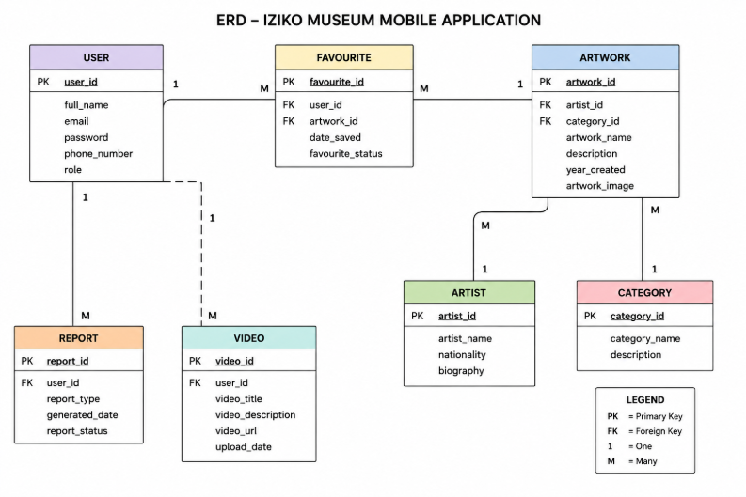

The database design for the Iziko Museum Mobile Application provides a structured way to store and manage system data. The entities and relationships were identified from the system requirements and normalized to Third Normal Form (3NF). Primary keys and foreign keys were used to maintain data integrity and establish relationships between tables. Sommerville (2016) states that a well-designed database improves system performance, scalability, and maintainability.

Entity Relationship Database Design

The Entity Relationship Diagram (ERD) shows all the database tables (entities) in the Iziko Museum Mobile Application and how they are connected to each other. Each table is shown with its Primary Key (PK) at the top and its fields below. Foreign Keys (FK) link tables together and show which tables share data.

Database tables and fields
- User — stores login and profile information (userID PK, username, email, password, userType).
- Artwork — stores artwork details including title, artist, year, description, image URL, and links to Gallery and Category via foreign keys.
- Gallery — stores gallery room information (galleryID PK, galleryName, location, floor).
- Category — stores artwork categories (categoryID PK, categoryName, description).
- QRCode — links each QR code to an artwork (qrCodeID PK, artworkID FK, qrData, generatedDate).
- Review — stores user reviews for artworks (reviewID PK, userID FK, artworkID FK, rating, comment, datePosted).
- Favourite — stores artworks saved by users (favouriteID PK, userID FK, artworkID FK, savedDate).
- Visit — tracks user visits in the app (visitID PK, userID FK, visitDate, duration, deviceType).
- UserActivity — tracks all user actions for reporting (activityID PK, userID FK, artworkID FK, actionType, actionDate).

Key relationships
A User can write many Reviews (one-to-many). An Artwork can receive many Reviews. Each Artwork belongs to one Gallery and one Category. A QR Code links to exactly one Artwork. A User can save many Favourite artworks. A User can have many Visits and many UserActivity records. Artwork is also tracked in many UserActivity records.

Figure 3: Entity Relationship Diagram (ERD)
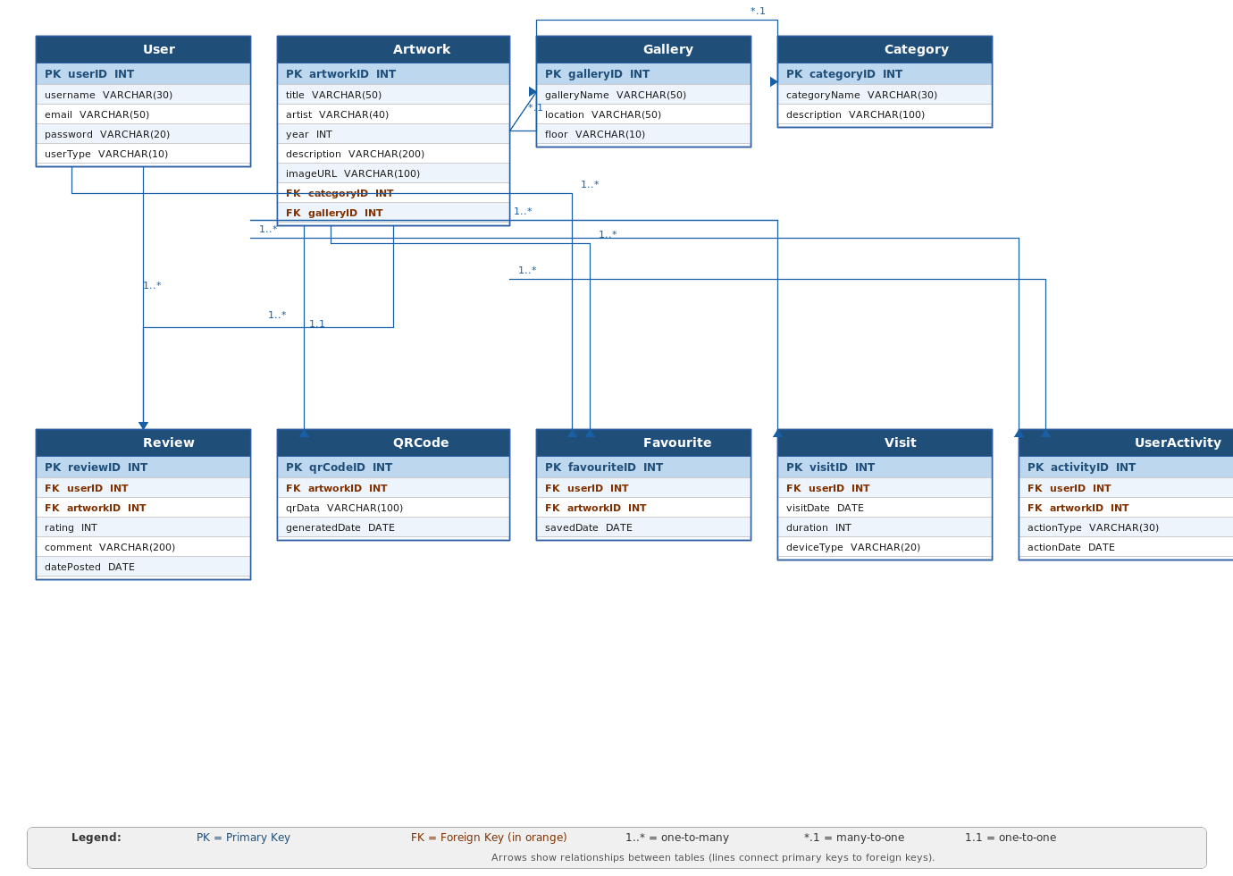
Figure 3: ERD showing all database tables, their fields, and their relationships for the Iziko Museum Mobile Application.

System Reports Design

The System Reports Design for the Iziko Museum Mobile Application was developed to assist administrators in monitoring, managing, and analyzing system activities. Reports provide useful information that supports decision-making, improves system maintenance, and helps track user interactions within the application. According to Hoffer, George and Valacich (2016), system reports are important because they provide meaningful information that assists organizations in evaluating system performance and operational activities.
The reporting system allows administrators to generate different types of reports, including user activity reports, artwork usage reports, multimedia usage reports, and security reports. These reports help administrators monitor how users interact with the mobile application and identify areas that may require improvement.

Types of Reports Table

Report Type | Description
User Activity Report | Displays user login activity
Artwork Usage Report | Shows most viewed artworks
Favourite Artwork Report | Displays saved favourite artworks
Multimedia Usage Report | Shows video and audio usage
QR Code Scan Report | Displays QR code scans
System Error Report | Displays system errors
Security Report | Displays security activities
Backup Report | Shows backup history
The different report types were designed to improve administrative monitoring and decision-making within the system (Kendall and Kendall, 2019).

Report Input and Output Design
The reporting system allows administrators to enter report criteria and generate reports automatically. Input data includes report type, report date, user information, and artwork information. The system processes the information and generates organised output for administrative purposes.

Input Data Table

Input Data | Description
Report Type | Type of report selected
Start Date | Beginning report date
End Date | Ending report date
User ID | User identifier
Artwork ID | Artwork identifier

Output Data Table

Output Data | Description
Report Number | Unique report ID
Generated Date | Date report generated
User Information | User activity details
Report Statistics | Report summary
Export Option | Download or print report

Example Report Layout

Report 1: User Activity Report
Report Design Table
Field Name | Description
report_id | Unique report number
generated_date | Date generated
user_id | User involved
login_time | Login time
logout_time | Logout time
activity_status | Activity status

Example Values
report_id | generated_date | user_id | login_time | activity_status
R001 | 2026-05-10 | U001 | 08:00 PM | Successful
R002 | 2026-05-11 | U002 | 09:30 PM | Successful
R003 | 2026-05-12 | U003 | 10:15 PM | Failed Login

Report 2: Artwork Usage Report
Insert Table
Field Name | Description
artwork_report_id | Unique report ID
artwork_id | Artwork identifier
artwork_name | Artwork name
number_of_views | Total views
search_count | Search total

Example Values
artwork_report_id | artwork_name | number_of_views | search_count
AR001 | African Sunset | 250 | 100
AR002 | Heritage Roots | 180 | 75
AR003 | Cape Memories | 300 | 120

Report 3: QR Code Scan Report
Field Name | Description
qr_report_id | Report number
qr_id | QR Identify
artwork_id | Artwork linked
scan_date | Date scanned
scan_count | Total scans

Example Values
qr_report_id | qr_id | artwork_id | scan_count
QRR001 | QR001 | A001 | 150
QRR002 | QR002 | A002 | 95
QRR003 | QR003 | A003 | 210

System Report Process

The reporting process follows several steps to generate reports within the system:
1. The administrator selects a report type.
2. The administrator enters report criteria.
3. The system retrieves data from the database.
4. The report is generated automatically.
5. The administrator can view, print, or export the report.
According to Sommerville (2016), automated reporting systems improve efficiency and support better system management.

Security and Access Control

Only authorized administrators are allowed to access and generate system reports. Authentication and access control mechanisms are implemented to ensure data confidentiality and system security. Kendall and Kendall (2019) explain that access control is important for protecting organizational information and preventing unauthorized access.
In conclusion, the System Reports Design for the Iziko Museum Mobile Application provides administrators with organized and accurate information regarding system activities, user interactions, and application performance. The reporting system improves monitoring, decision-making, and security management within the application. The report structure also supports future scalability and system maintenance (Satzinger, Jackson and Burd, 2016).

References

Hoffer, J.A., George, J.F. and Valacich, J.S. (2016) Modern Systems Analysis and Design. 9th edn. Harlow: Pearson.
Kendall, K.E. and Kendall, J.E. (2019) Systems Analysis and Design. 10th edn. Harlow: Pearson.
Satzinger, J.W., Jackson, R.B. & Burd, S.D., 2016. Systems Analysis and Design in a Changing World. 7th ed. Boston: Cengage Learning.
Sommerville, I. (2016) Software Engineering. 10th edn. Boston: Pearson.

Github

GitHub Link :

ST10438554-kirby/XISD5311_IZIKO_ARTGALLERY

What can be found on GitHub:
- XISD5311_Task 1
- Analysis Document
- System Design Document

